


TREE OF LIFE

Erol Çelik
2022510164

2024/2025 FALL
CME 2201- Assingment 2
Dr. Feriştah DALKILIÇ

>Introduction

In computational biology and data structures, tree-based representations are fundamental in organizing hierarchical data. Amongst the most important applications of such data structures are those in evolutionary biology, where trees, called phylogenetic trees, model relationships between various species. This project will implement a “General Tree” structure and apply it to explore and manipulate evolutionary data.

This project, through the implementation of a custom tree, models the processing of data about biological species. This enables us to explore various operations, including “pre-order traversal”, “ancestor path finding”, and “subtree investigation”. The nodes of the tree represent species, and the edges represent an evolutionary relationship between those species. Other important points that were implemented include computation of the “degree”, “height”, and “breadth” of the tree, very useful measures to analyze hierarchical data.

In this project, we tried to address issues such as the implementation of an effective traversal mechanism, sustaining the relationship in a tree-like manner, along with edge cases related to either isolated nodes or unbalanced trees. Furthermore, in ensuring that all methods executed have no dependencies on pre-implemented Java libraries, this will actually mean core variabilities of data structure and algorithm design are implemented in real ways. This report documents the design, implementation, and results of the project, emphasizing its utility in representing complex biological data.

>Data Structures

Interfaces
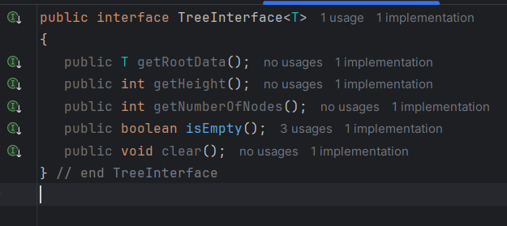
This `TreeInterface` describes the core operations common to all trees, including getting the root data, calculating height and number of nodes, whether a tree is empty, and how to clear a tree, so it's the interface used to implement different representations of hierarchical data. Also ‘TreeIteratorInterface’ used for generating pre-order travel.

Species Class
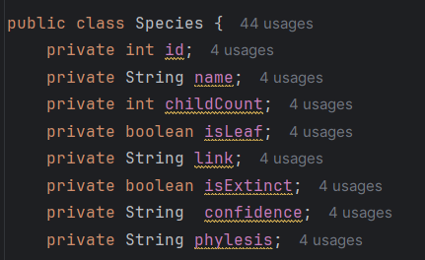
The `Species` class models individual biological species in the tree structure. It wraps the key attributes of the species, like species ID, name, and extra metadata about confidence levels or relationships, in a tidy fashion, such that evolutionary data can be stored and manipulated efficiently.

General Tree Class
The GeneralTree class represents the custom implementation of a tree for modeling the hierarchical relationship between species. Every node within a tree can have more than one child; it is thus appropriate to model rich evolutionary data. It implements methods for node addition, tree traversals of multiple orders, metric calculation, such as height and degree, and also efficiently manages parent-to-child relationships. It allows flexible extension to enable robust manipulation and analysis of biological data in a flexible and extensible way.
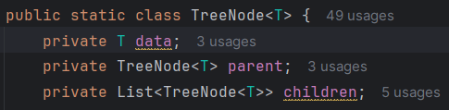
Data can be kept through TreeNode inner class.

In addition to these, list hashmap stack queue and array were used in the java library where necessary.

>Implementions
Getting Media from the csv file by loadDataTree()
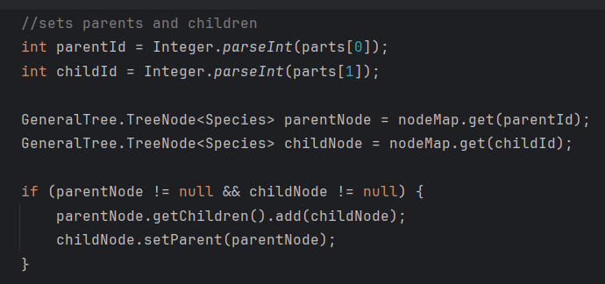
has two parts. In the first part, the lines are read from the csv file, split and new nodes are created according to the attributes. Also an helper method parseCSVLine() used.
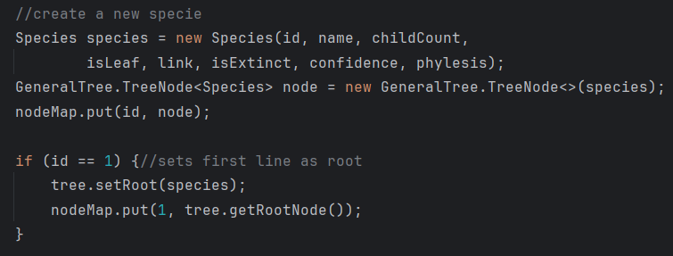
In the second part, the files are read as same and the ancestors and children of the required nodes are linked.
Search Species Method gets an input to search and prints data’s informations.

Writing Tree in Pre-Order Traverse
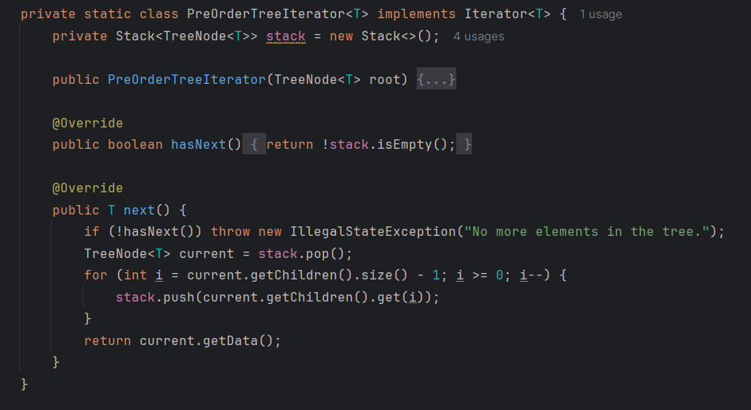
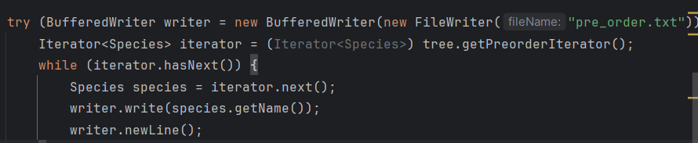
The overridden iterator is called from the interface. The entire tree is kept in the stack while being traversed in the pre-order order. Then it is written to the txt file.

Subtree PreOrder Traversal
The purpose of this feature is to print a subtree of any given species in “pre-order traversal” format. The implementation uses an iterative method with a stack for node traversal. For every node, it prints the ID, the name, and whether it is a leaf `(-)` or has children `(+)`. This manages the indentation level through an auxiliary stack that keeps track of each node's depth to correctly provide the hierarchical format. Stack structure and iterators are used as method before.
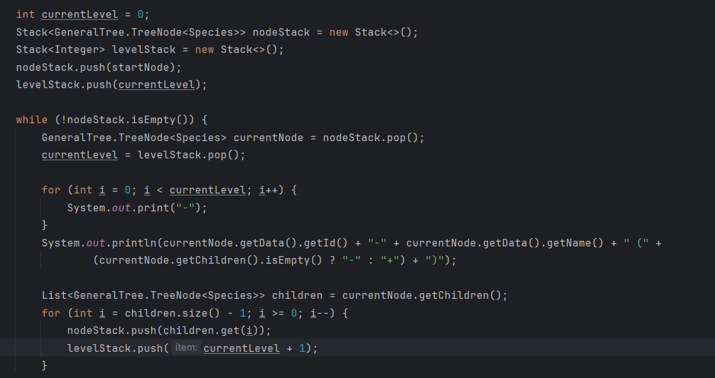

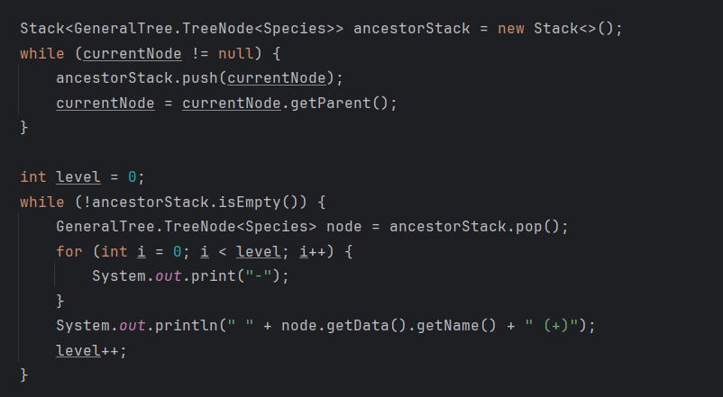
Ancestors Path
This feature prints the ancestor path of a given species by traversing upward from the target node to the root using parent references. The implementation uses a HashMap (nodeMap) for efficient node retrieval and a stack to reverse the order of traversal, ensuring the path is printed from the root to the target node in the correct hierarchical format.

Common Ancestors
Two inputs are taken from the user and their ancestors are found by comparing.
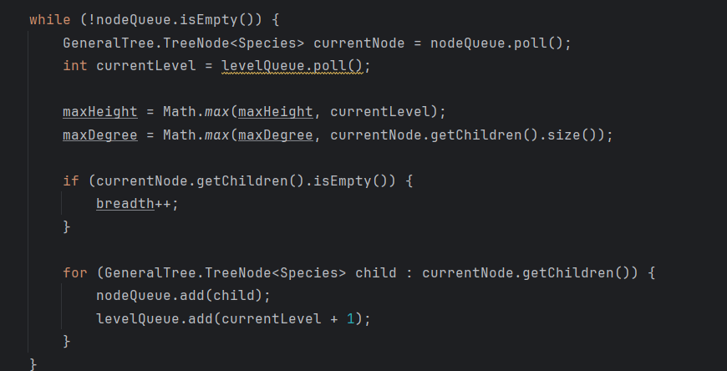

Heigh Degree and Breadth
calculates the tree's height, degree, and breadth by holding in queue.
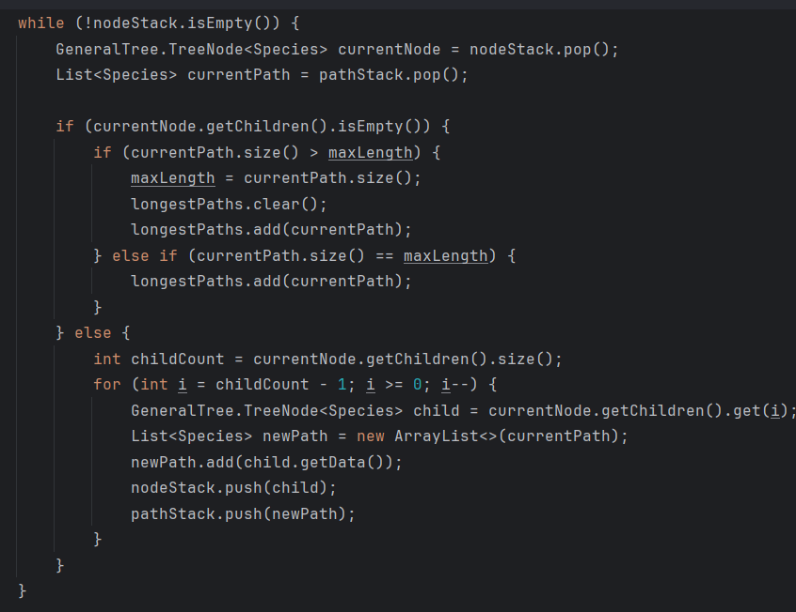
Longest Evolutionary Path\Paths
A Stack is used to store nodes to be processed, while a parallel Stack maintains the current path for each node.As nodes are processed, their children are added to the stack alongside updated paths. If a node is a leaf, the current path's length is compared to the longest path found so far. Paths are stored in a List to track all paths of maximum length. This approach ensures the tree is processed iteratively, avoiding recursion while efficiently handling path tracking.

